1. User paste the url of web and its appeared proper website-

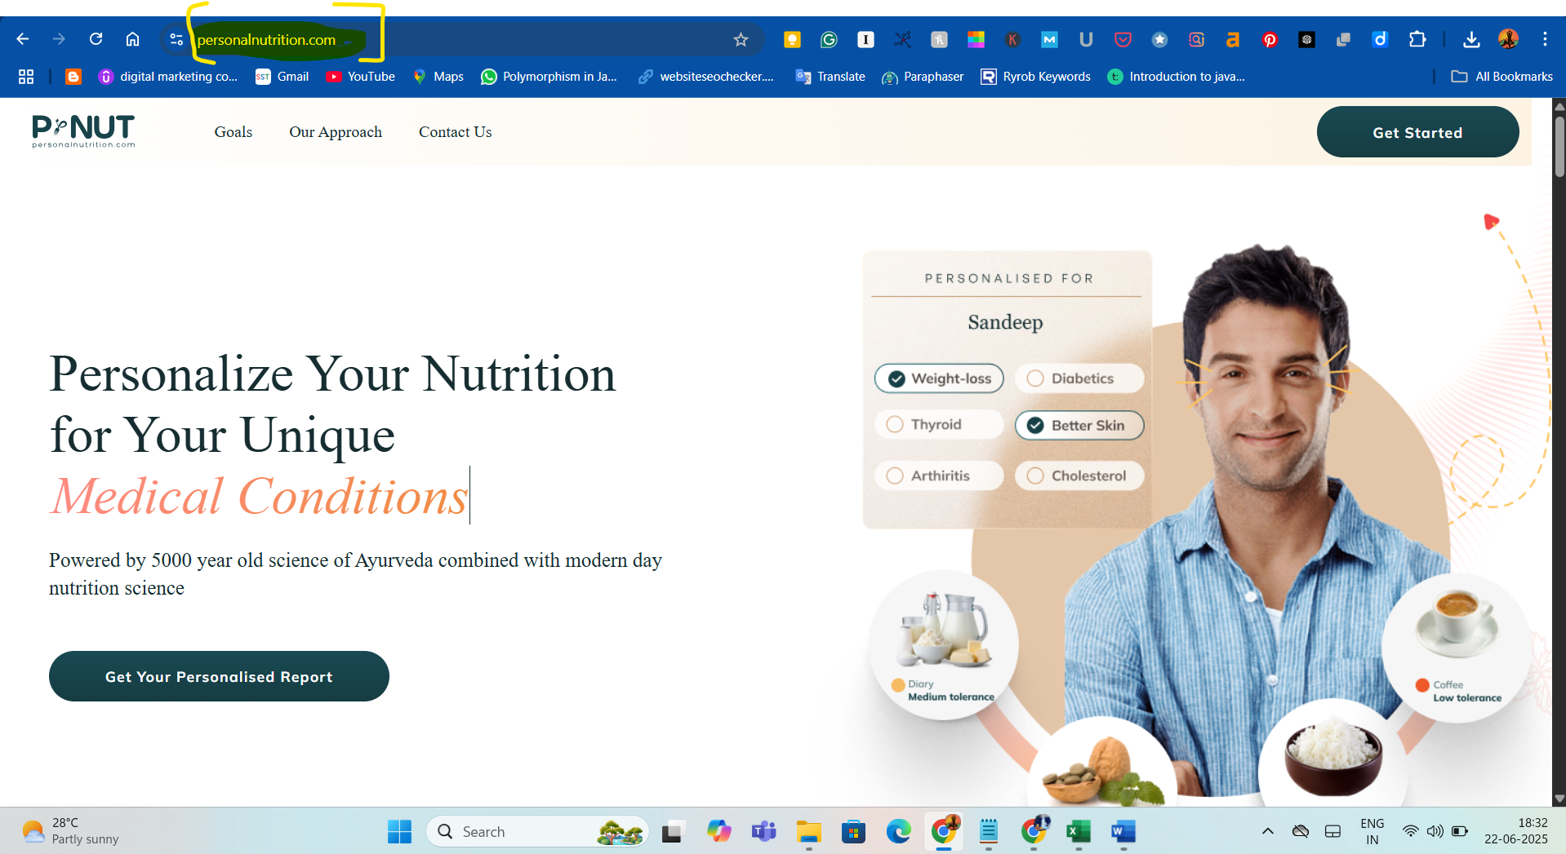

1. Try opening website with incorrect URL <https://personalnutrition.com->

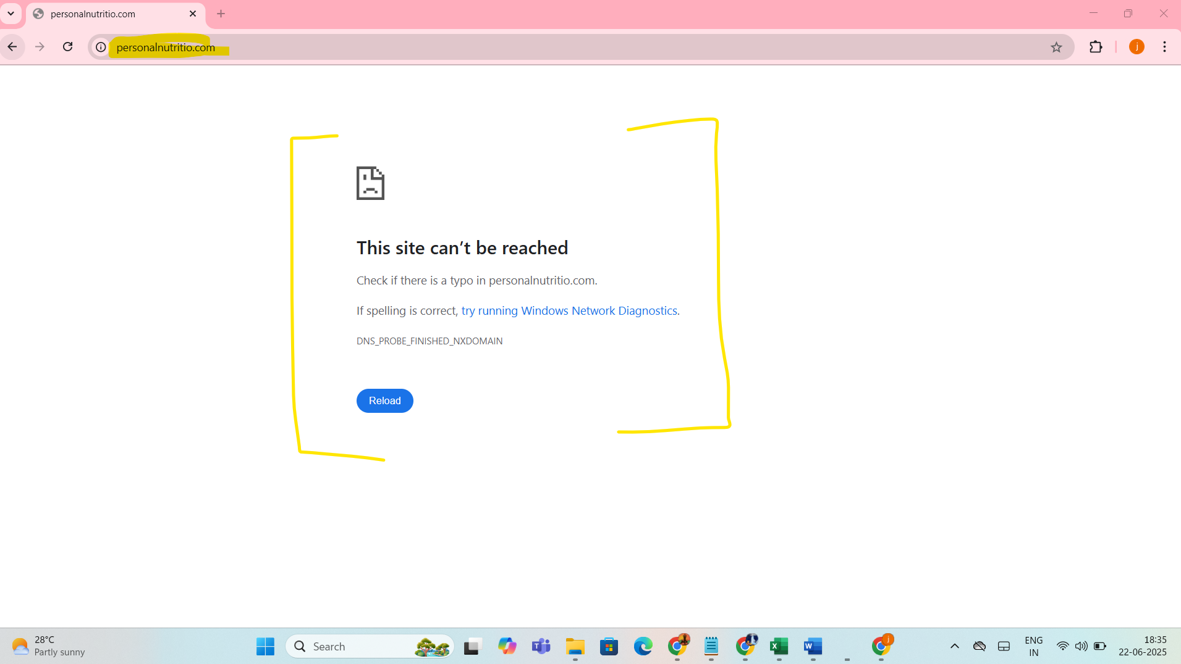

1. Click on each top menu item and user redirected to correct page-

Goal page-

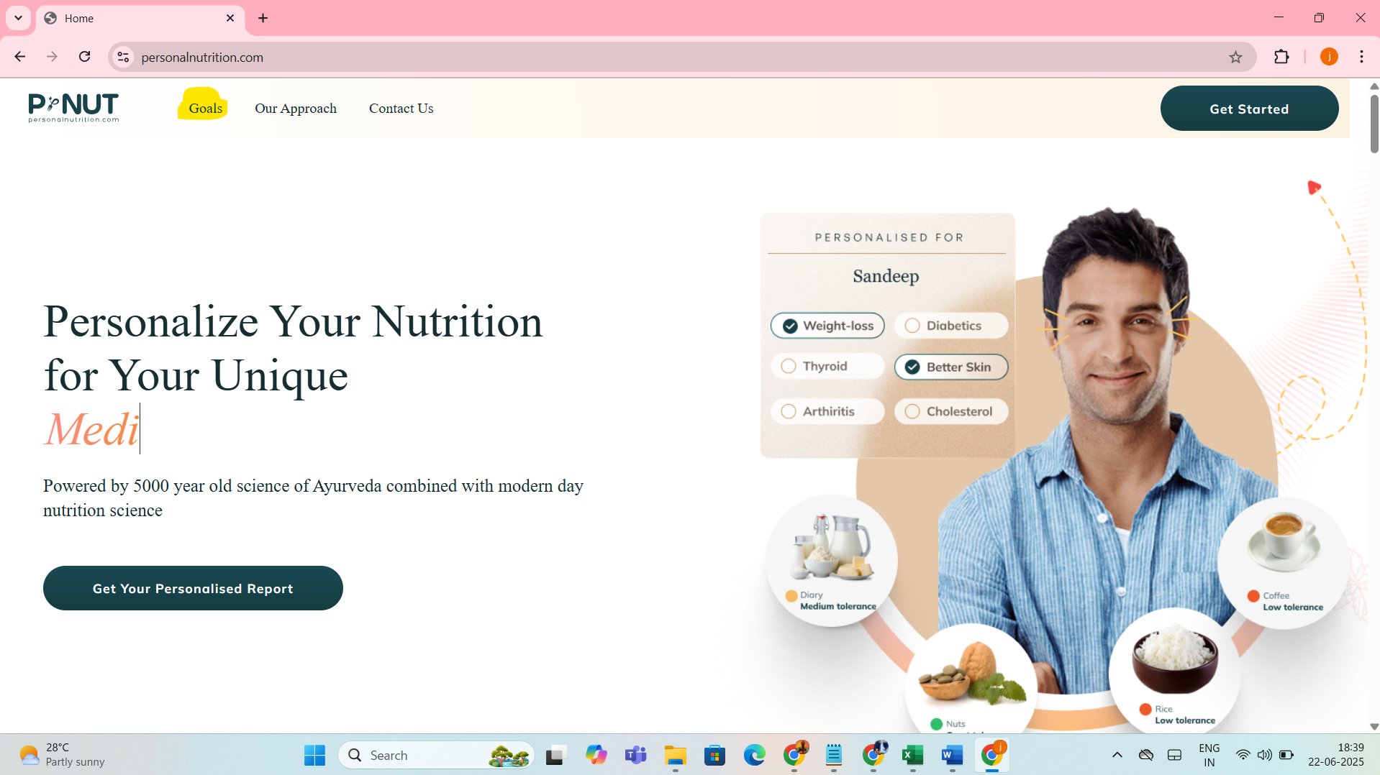

Contact Us Page-

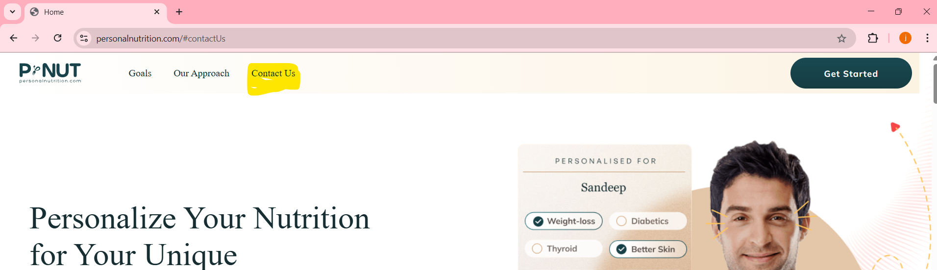

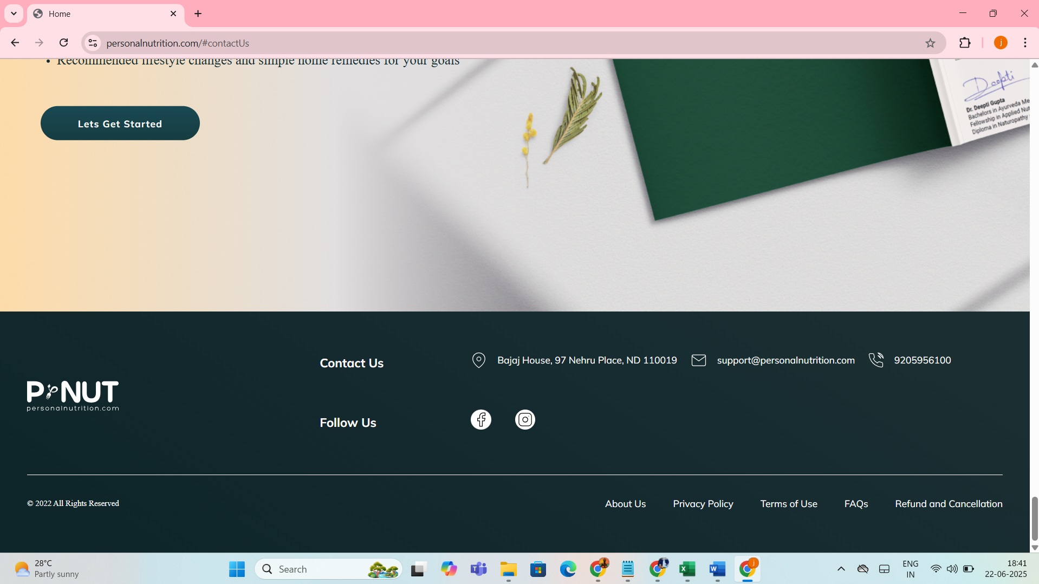

1. When User click on any tab, the user fill all details properly.

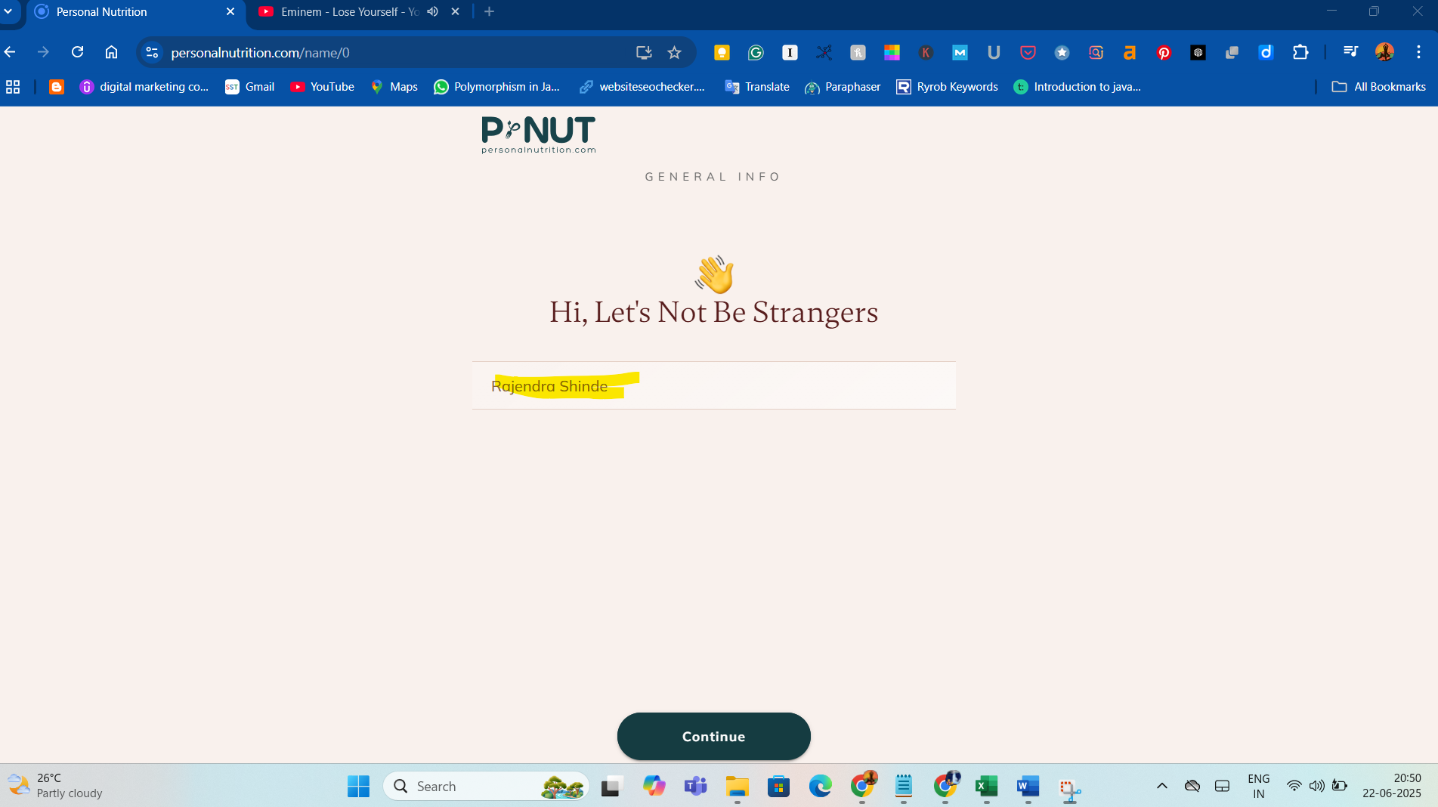

1. User fill email ID and phone number-

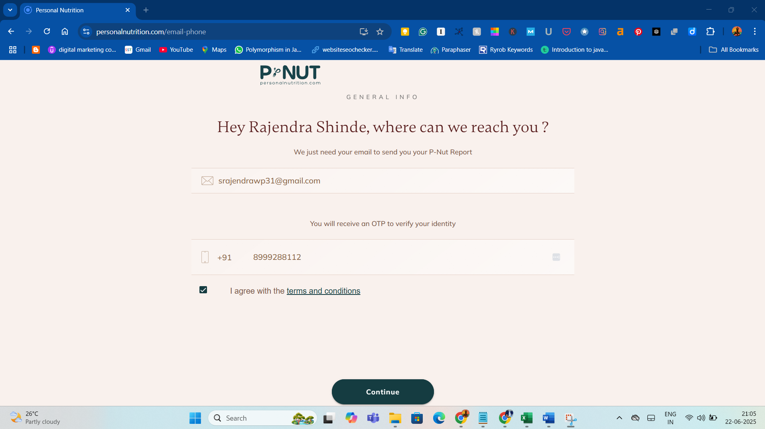

1. When User click on footer links, User redirected internal/external destination-

User click on About Us footer link-

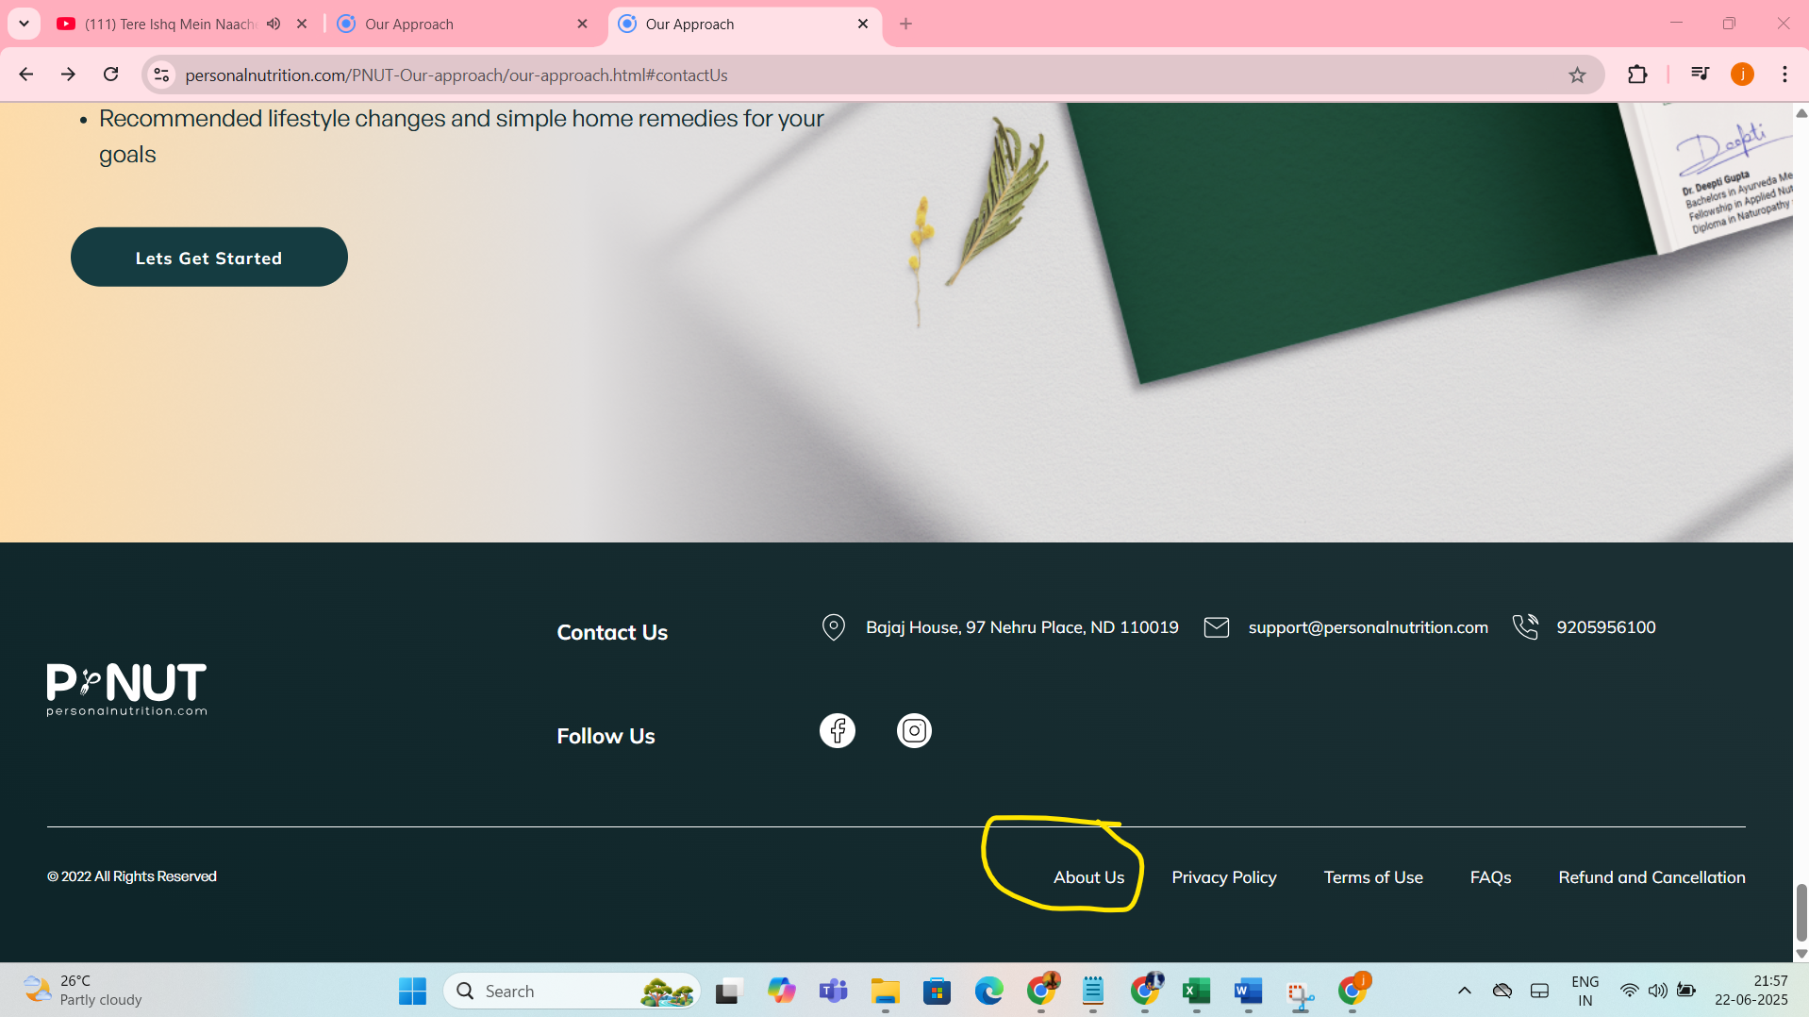

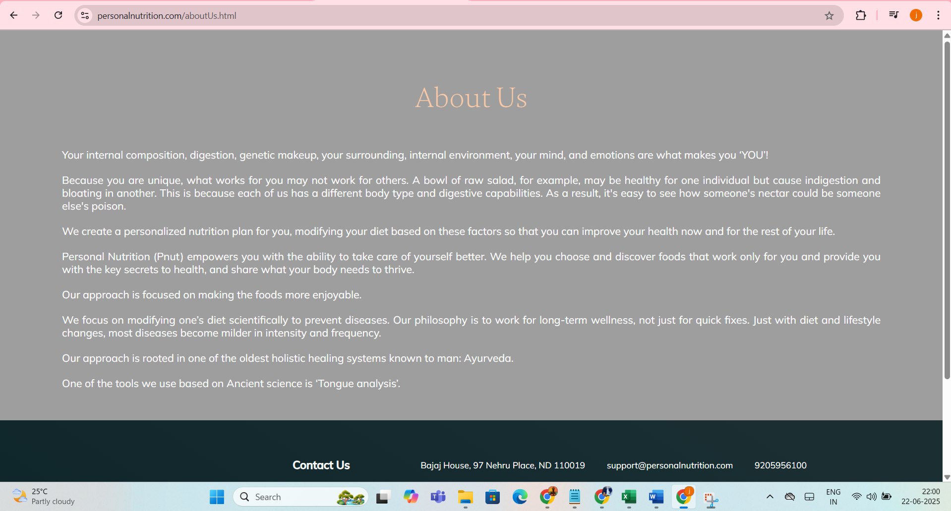

When User click on privacy policy link-

